Google Analytics

**Signing up**

<https://analytics.google.com>

You must have a google email account.

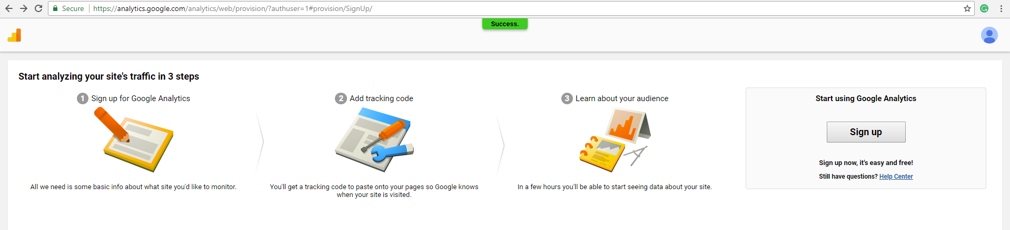

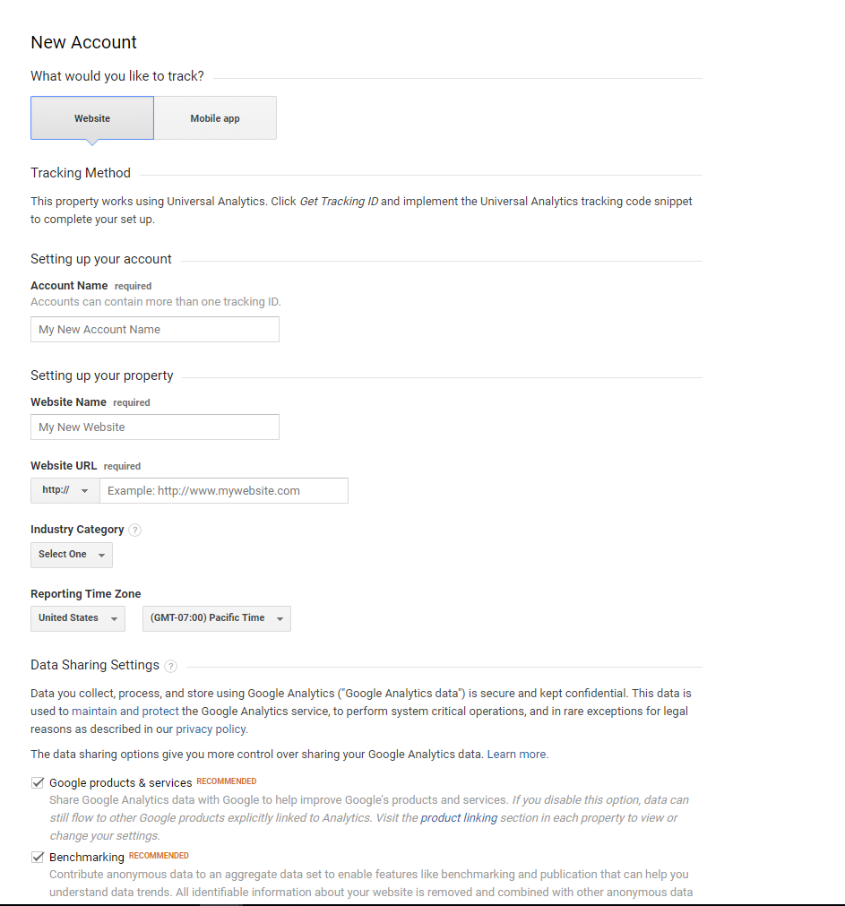

Fill out the details as to the form.

Account Name: Centium  
*User your name or company name*

Website Name: EventsAIR  
*This website is a quick reference to data tracking as we are using this for EventsAIR, I will name mine EventsAIR*

Website URL: centium.eventsair.com  
*Use your URL alias*

Industry Category: IT  
*Your business Category*

Reporting Time Zone: Australia (AEST 10+)  
*This will display the time someone visiting your website.*

**After Signing up**

The below image will be the first thing you will see after making a google analytics account. The Tracking ID is NOT the ID you require for EventsAIR.

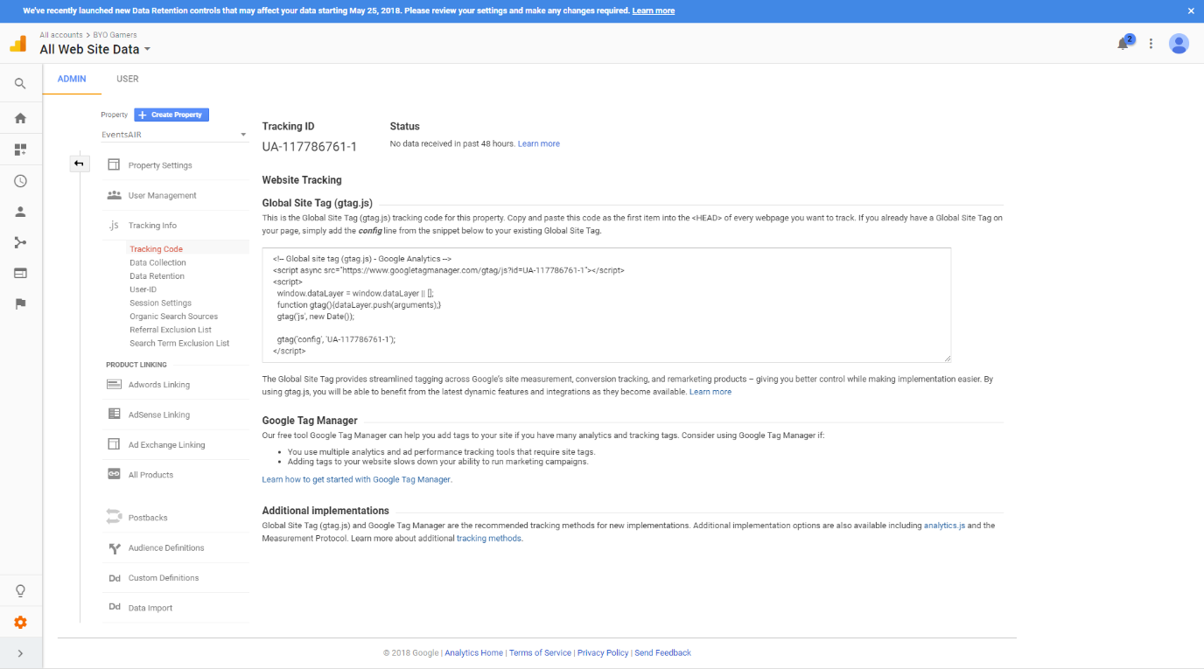

First click on the orange cog on the bottom, this will bring you to your main overlay.

From here your Google Analytics will be broken into 3 columns.  
**Account**: Your account details  
**Property**: The Website  
**View**: The type of data your viewing

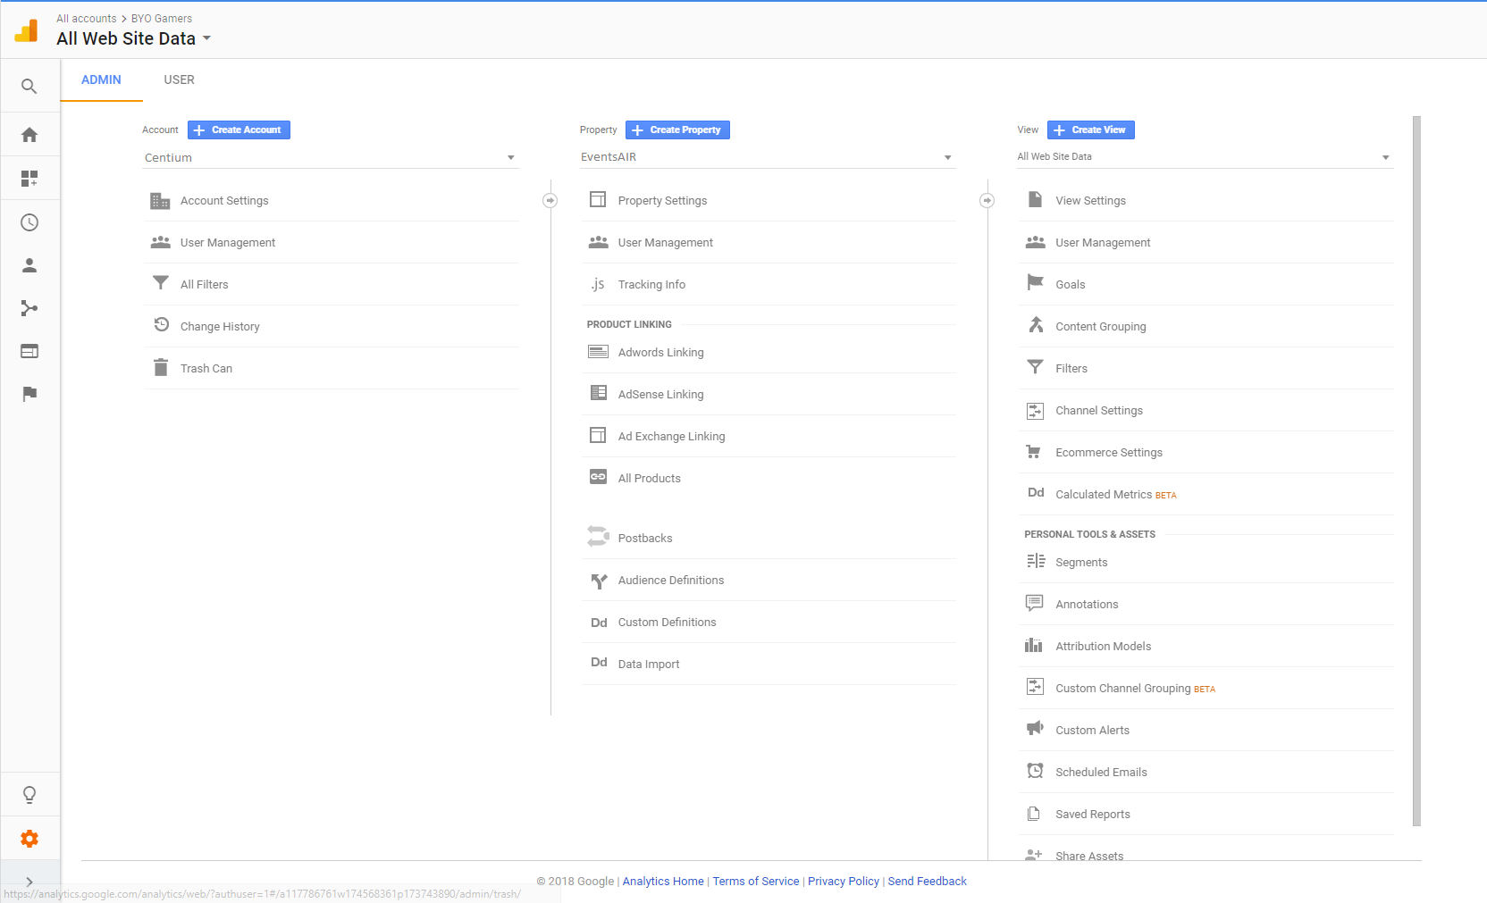

To find the details required for EventsAIR, click on “**Account Settings**” under the “**Account**” column

Here you can find the following detail you require.  
Account ID:  
Account Name:  
Email: (This is the email you used to register the google analytics)  
  
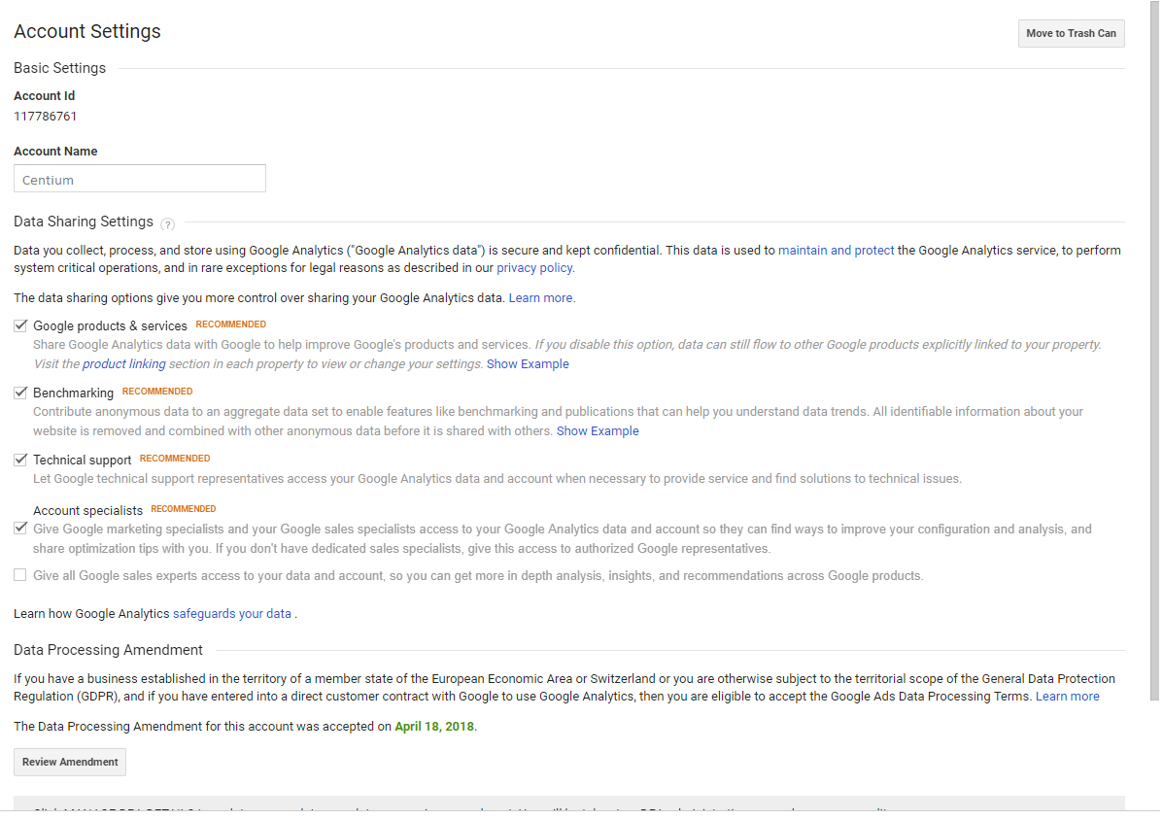

Place these details into EventsAIR, follow the screenshots below:  
*Don’t forget to enable Google Analytics in your event at the end.*  
  
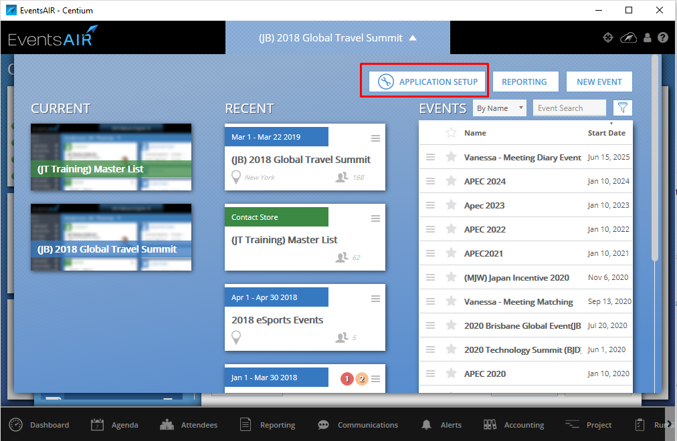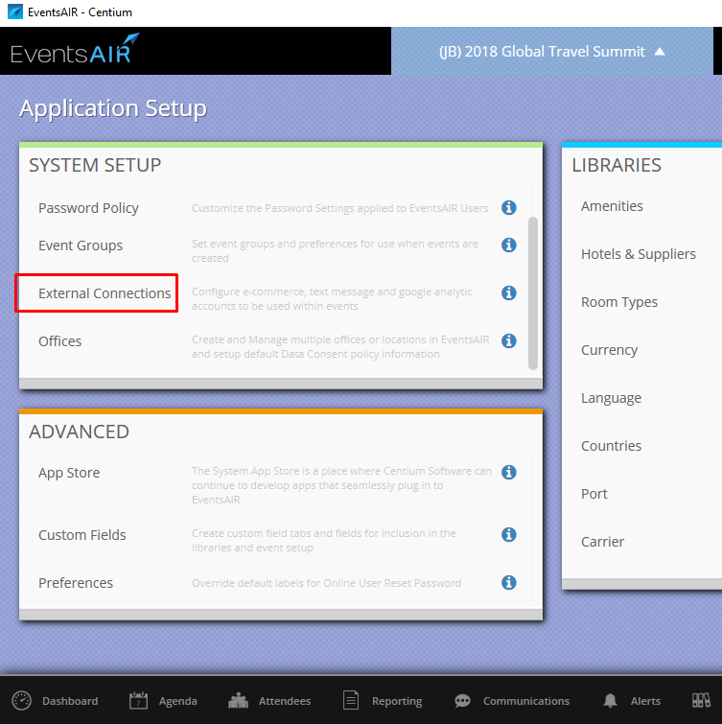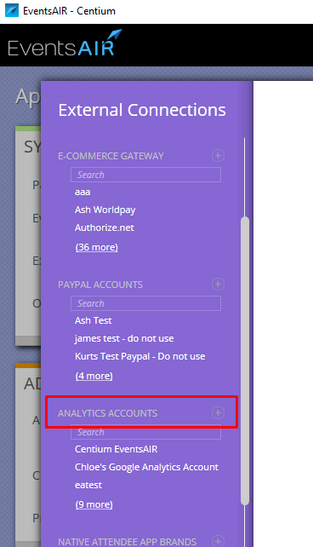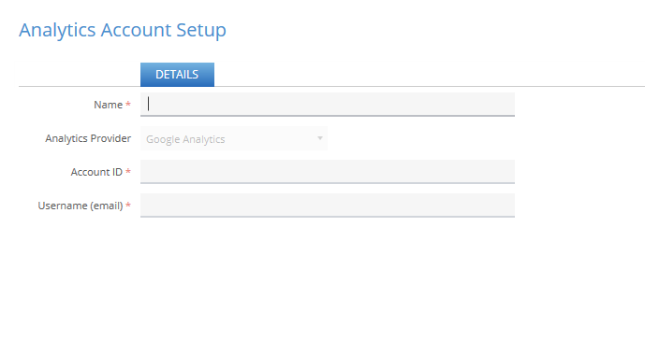

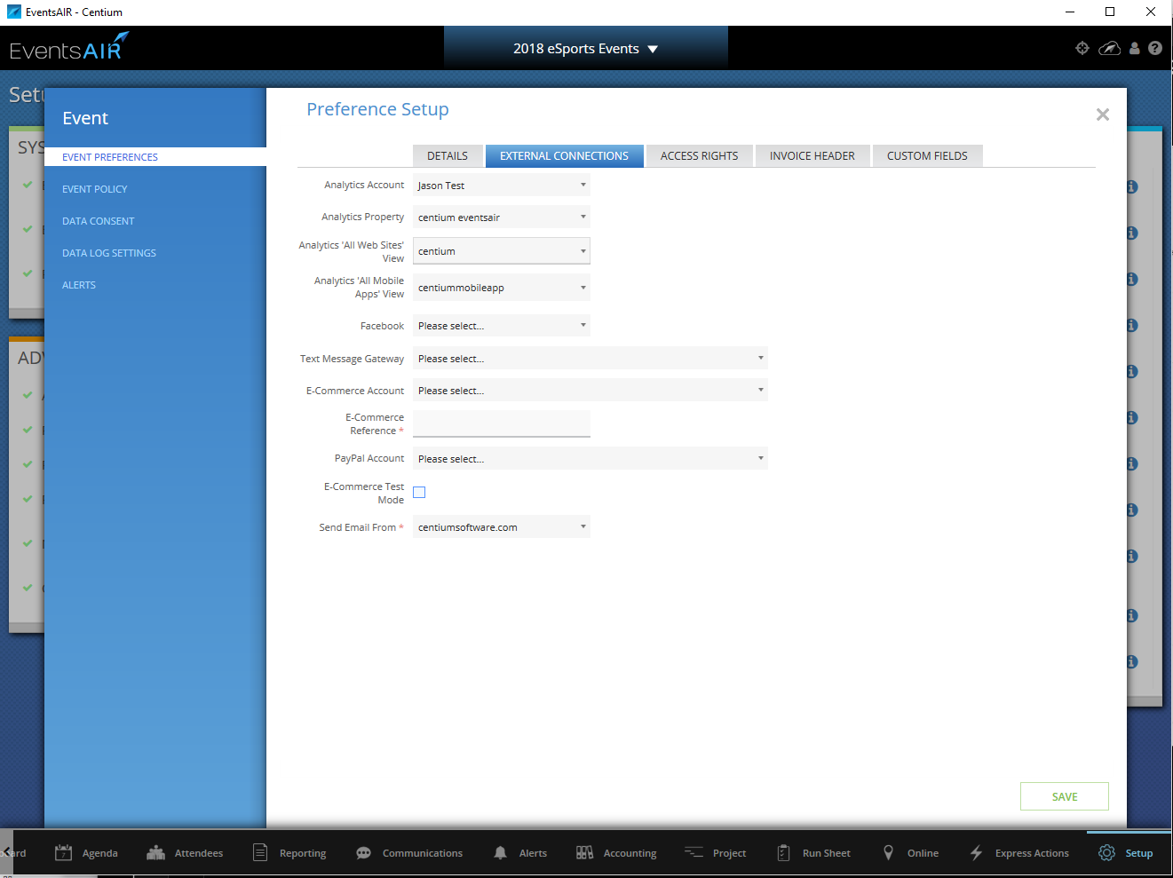

Mobile App

To register your Google Analytics for mobiles app you are required to create a new view.

This is found on your admin page in the 3rd (right) column.

Create a new view, this will bring you to page with 2 options website or Mobile app.

View Name:

Time zone: (set as the same as your website time)

Once you have completed this view with the mobile option it will be unlocked in EventsAIR.

You must go to the External Connections in your event to enable this option.

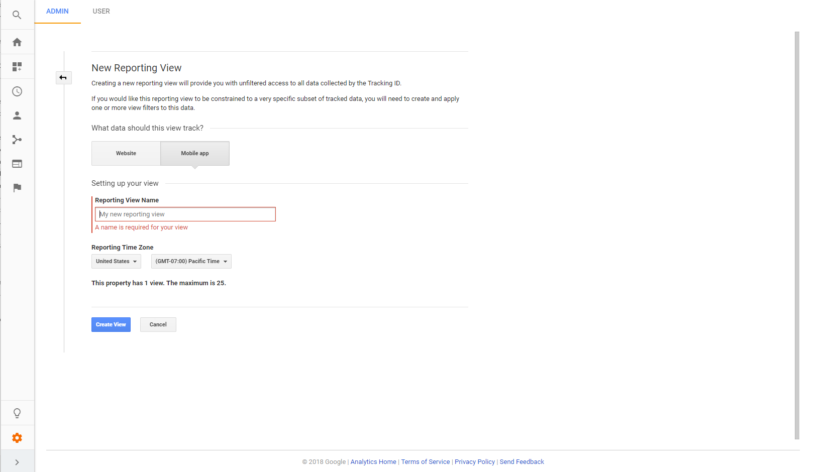

Website Tracking

To enable website tracking you are required to copy and paste code from google analytics into your EventsAIR website.

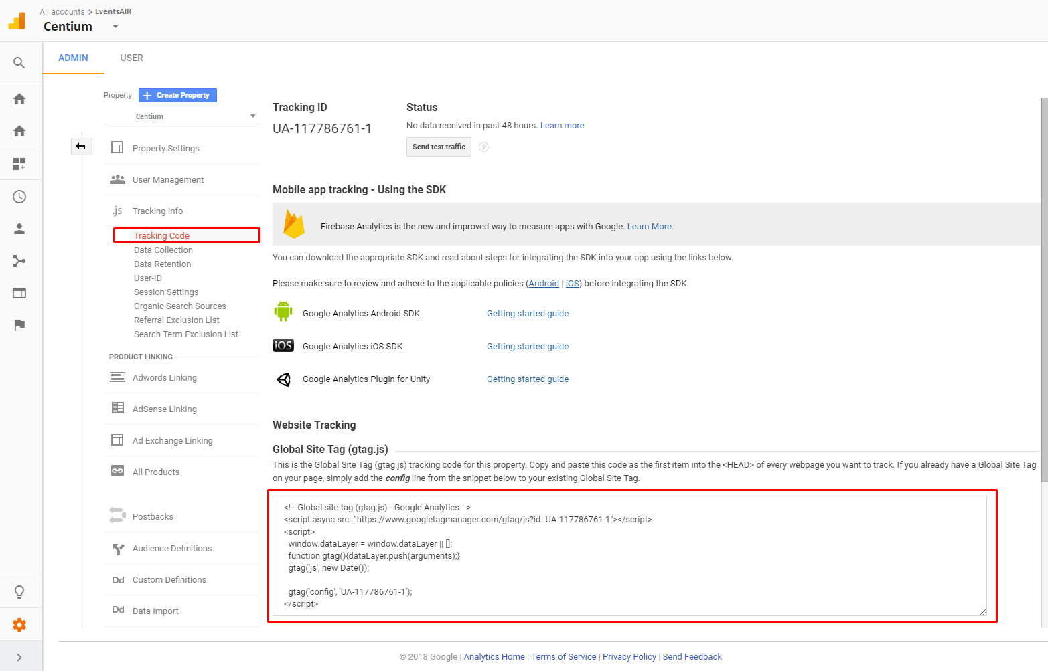

The code is to be pasted into your registration site. This is how you enable this site to be tracked.

